The Carnival of the Animals

First listen to each of the 14 movements in order and make notes about their musical characteristics (pitch, tempo, dynamics, texture and timbre)
Next play the songs out of sequence.
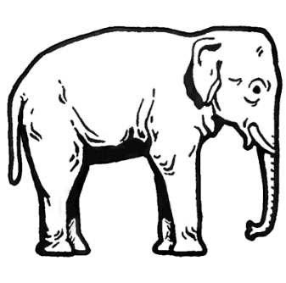
Can you match the songs to the correct animal?

1 | Introduction et marche royale du lion | Introduction and Royal March of the Lion
2 | Poules et coqs | Hens and Roosters
3 | Hémiones (animaux véloces) | Wild Donkeys Swift Animals
4 | IV "Tortues | Tortoises
5 | L'Éléphant | The Elephant
6 | Kangourous | Kangaroos
7 | Aquarium
8 | Personnages à longues oreilles | Characters with Long Ears
9 | Le Coucou au fond des bois | The Cuckoo in the Depths of the Woods
10 | Volière | Aviary
11 | Pianistes | Pianists
12 | Fossiles | Fossils
13 | Le cygne | The Swan
14 | Final | Finale

